SDG Streetlight Script Set Up Guide:

**Step 1: Setting up Street Smart**

Set up Street Smart first so you can easily get the mouse coordinates and start data collection.

*First go to the map on Street Smart then zoom until you see the street view points*

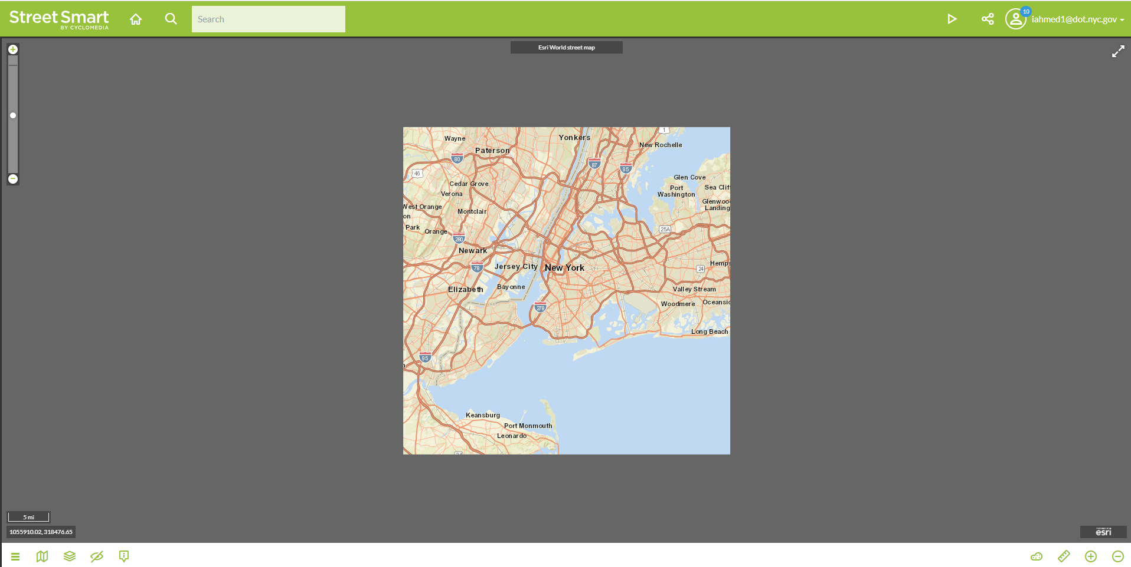

When you zoom in you should see the green street view points:

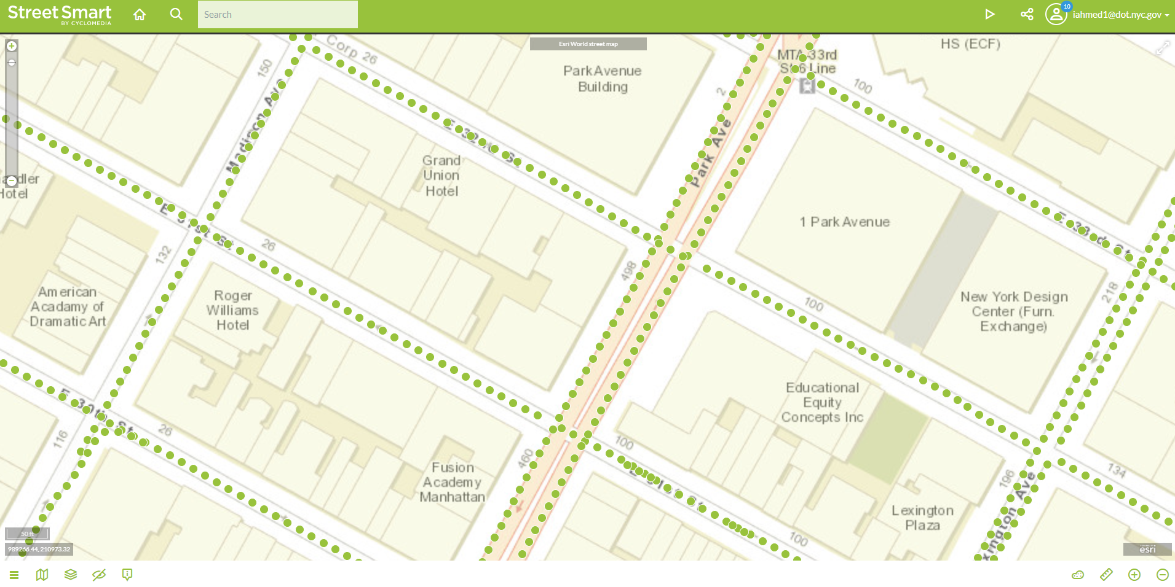

Click one point so it opens up the street view with the tab on the right. After the tab is open click on the start measuring ruler. It is located on the lower right, as shown below:

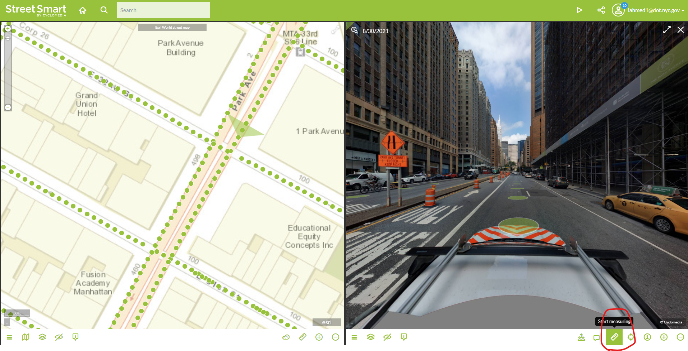

After clicking the measuring ruler, select the location option for measurement type, as shown below:

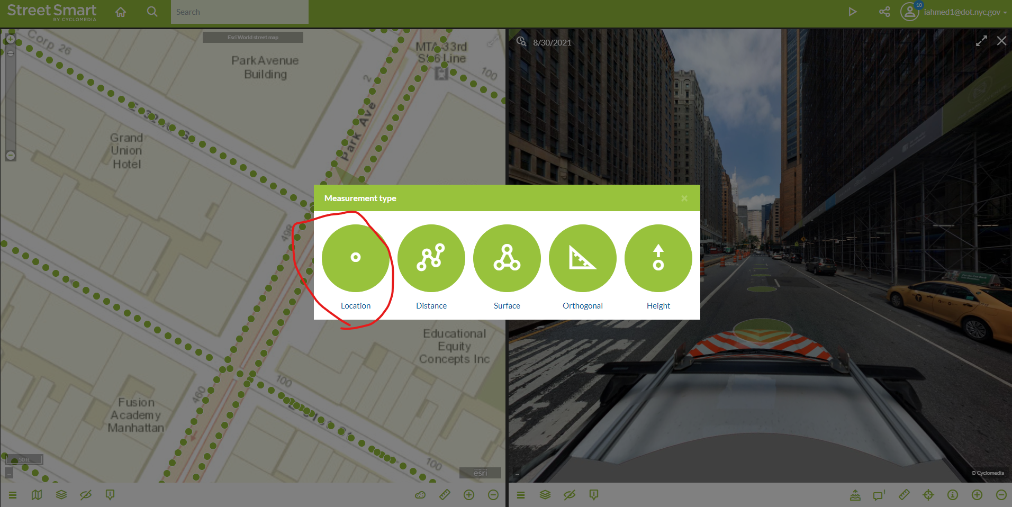

This should open up a tab with a bunch of information regarding points on the right.

Something like this:

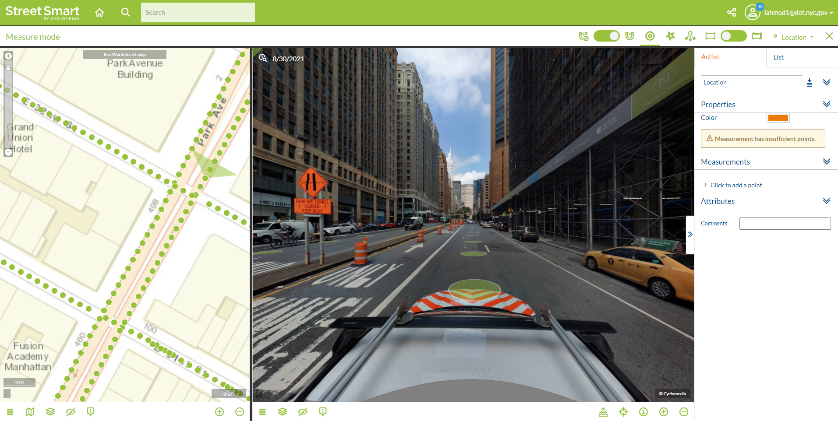

Right now you may notice it says “Measurement has insufficient points”. In order for the python script to properly work we will have to first click a point so we can see the properties.

Click any point the street view map, which will show an orange marker on the left map and properties on the right tab. You should have something like this:

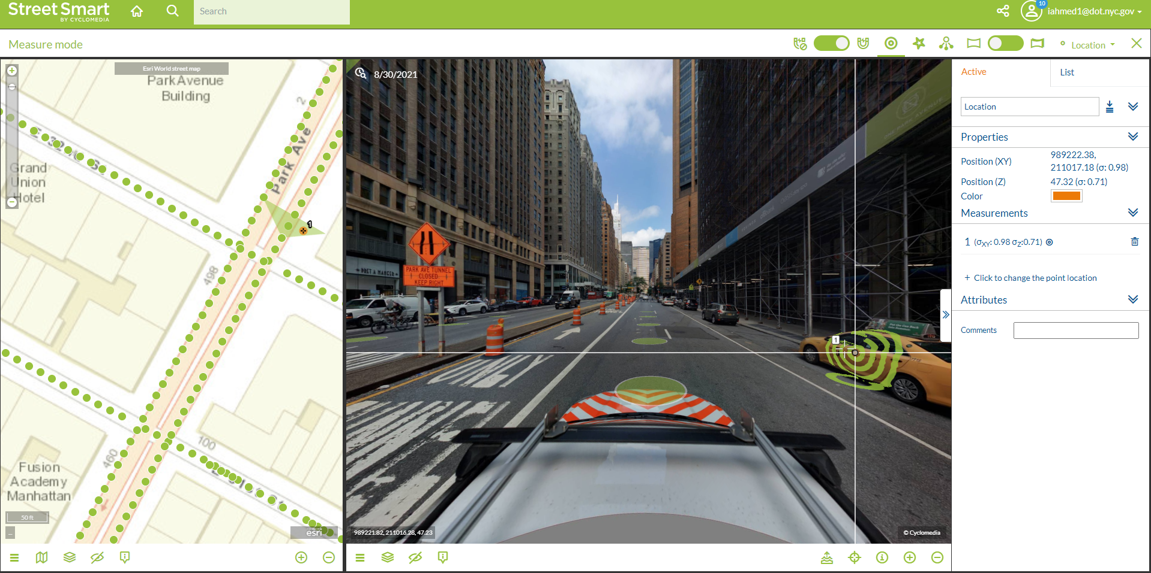

Now make sure to click the color button so you can see all the options. When your right tab looks like this you can move forward to setting up the python script:

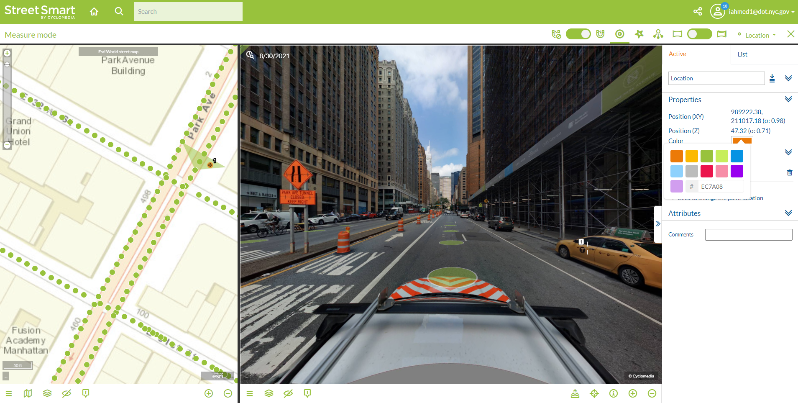

**Step 2: Setting up the python script**

Now you can open the python application from the folder you just downloaded it from.

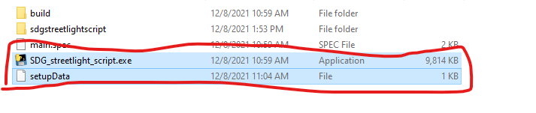

**Make sure you have the application (.exe file) and setupData file in the same folder. If you lose setupData file you will need to repeat setting up the script again. **

When you open the script two windows pop up, one is a terminal that runs in the background. Focus on the Main Window that has 3 buttons. You want to first click Set Up Tutorial:

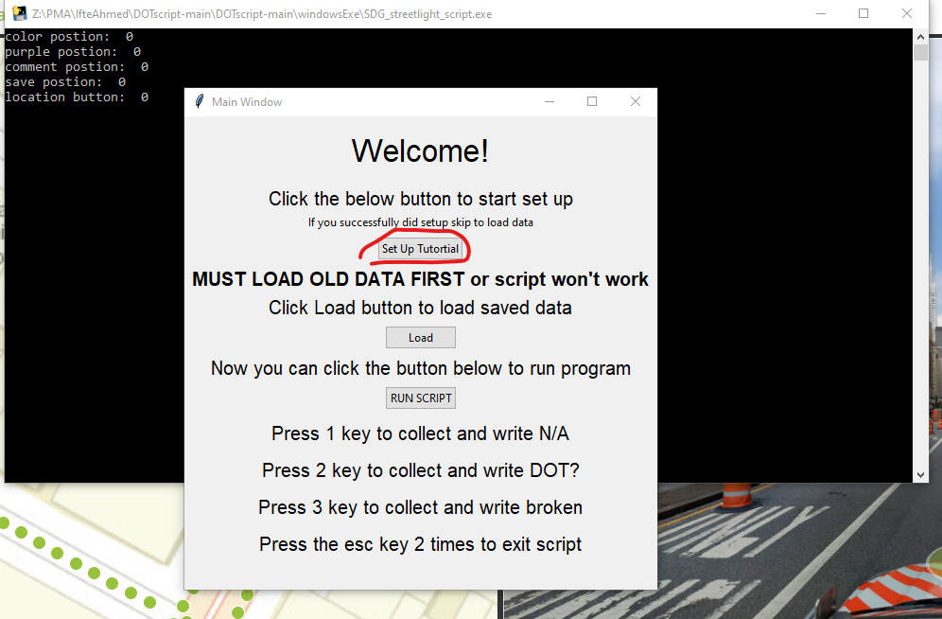

After you click that button, another window opens that gives you 5 step directions to setting up the python script.

Something like this:

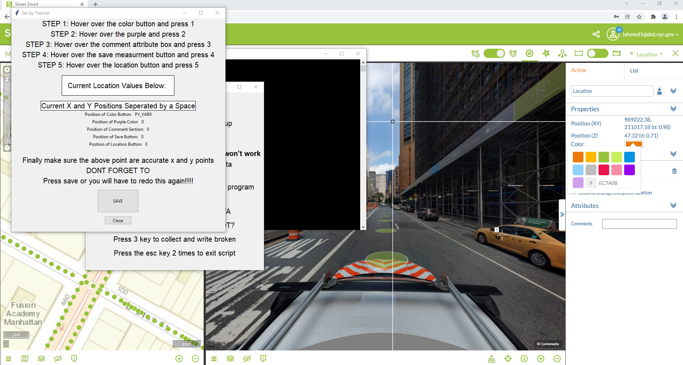

** Make sure you do not click anything else and keep this window selected**

**Also make sure when you are saving the mouse coordinates you hover over the spots and not click them**

So first hover over the color position and press 1 to record the mouse coordinates. When you do this you will notice the numbers changing in the “Position of Color Button:” section in the UI.

Example:

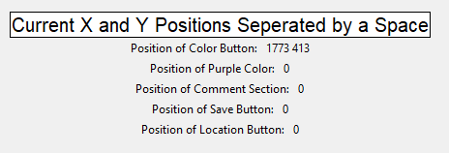 Color position changed

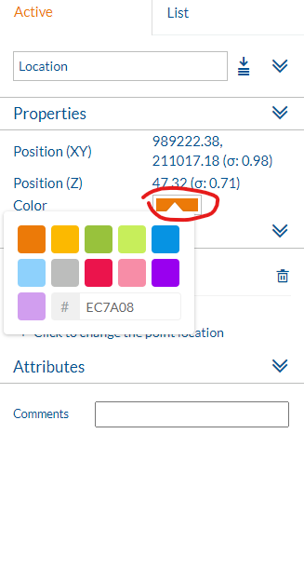 Hover at that circle.

Follow the same directions for the remaining 4 steps, screen shots with red circles of spots you need to hover.

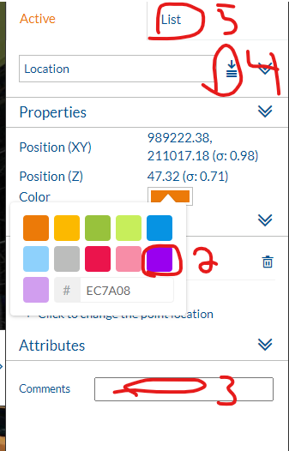 The spots are labeled and number in order.

After you have the finished you should see the points like below:

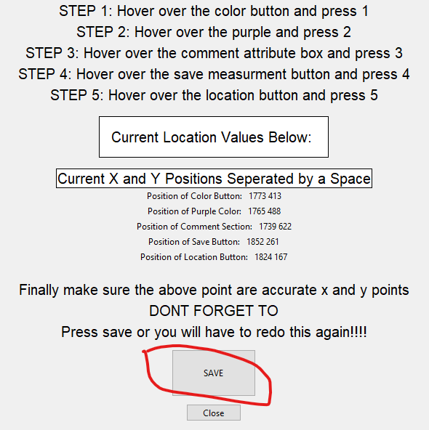

Now you can click the save button and close this window. Go back to the main window and make sure to load the data you just saved:

You can confirm that everything has worked by looking at the terminal:

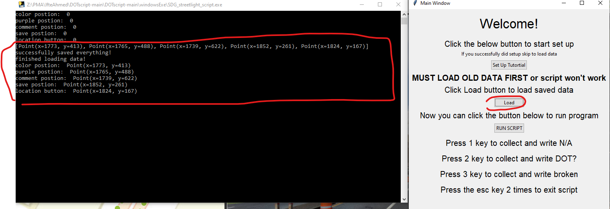

If you see the same thing as shown above, you can click the Run script button now.

This will allow you to press 1 to record points and write “N/A”, 2 for “DOT?” And 3 for “broken”. If you press the esc key it will close the script.

When you press run Script it will close the main window and only keep the terminal running in the background.

Now you can go back to Street Smart and follow the workflow (click a point, press 1 or the other keys and it automatically saves the point for you). After that move on to the next point.

** After the initial set up, you can close the script and just load the data file next time you want to collect points. This will only work if the setupData file is in the same folder as the application file. So you won’t have to repeat this process again, unless you lose the file or mess up the positions of the points **

**If the script is not running properly, please re try the set up tutorial and follow this guide or the video that will be provided **